File Sharing
One of the key services in an enterprise environment is shared file systems, where employees can save and share files with their workgroup. using SMB/Samba, enabling file sharing between the three operating systems (Linux Slackware, Solaris, Windows, and CentOS for groups of 3 students).

Now, we can detail the step-to-step SMB installation.
We will start with Samba installation in Solaris because it’ll be the way to share files in the other two VMs, so Slackware and Windows with GUI are clients that can see Solaris files.

0 — Preconditions & notes
- You need root privileges.
- Pick a server IP or hostname and make sure clients can reach it (ping <IP>).
- It’s recommended to use ssh service to connect the VM because of the need to not copy manually the commands, just as simple as copy and paste.

1 — SSH Service Installation (mentioned before depending on the VM)
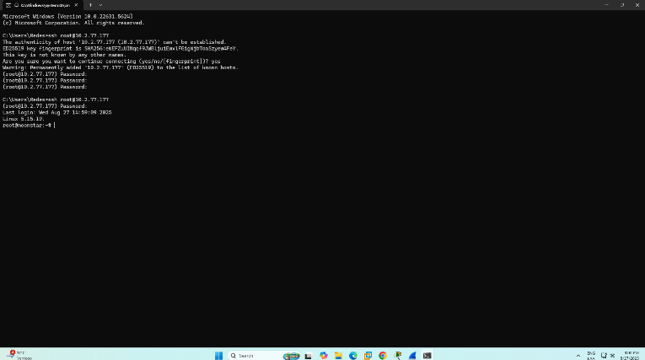

2 — Install Samba package in Solaris
- Install Samba on Solaris
First, we must check if Samba is already installed:

pkg list samba # or
pkginfo | grep -i samba
If not installed, install it:
pkg install samba
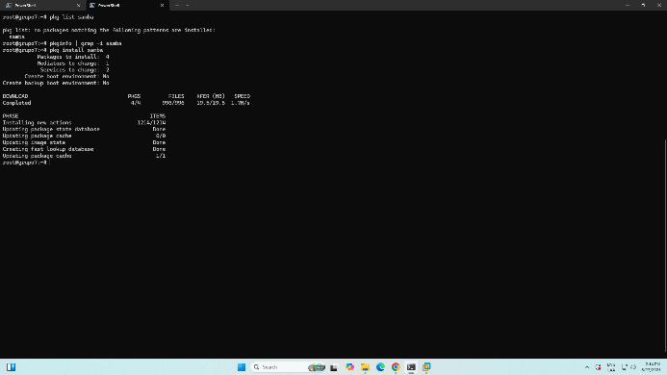

- Create Shared Directory
Create a directory to share:
sudo mkdir -p /export/shared
sudo chmod 755 /export/shared
sudo chown nobody:nobody /export/shared
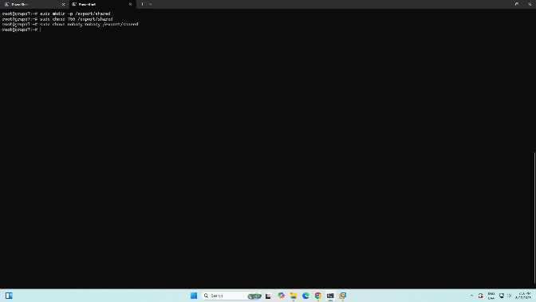
- Configure Samba
Edit the Samba configuration file (you can use vi editor or nano or cat):

[global]
workgroup = WORKGROUP
server string = Solaris Samba Server
security = user
map to guest = bad user
dns proxy = no

[shared]
path = /export/shared
browseable = yes
writable = yes
guest ok = yes
read only = no
create mask = 0777
directory mask = 0777
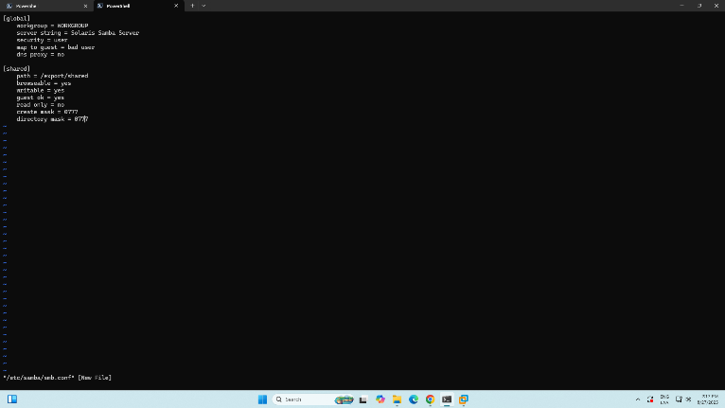

- Create Samba Users
Add system users and Samba users:

# Create a system user
sudo useradd -m smbuser

# Add user to Samba
sudo smbpasswd -a smbuser

# Enter password when prompted
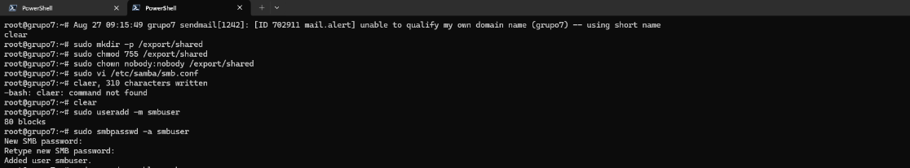

- Start Samba Services
Enable and start Samba services:

# For Solaris 11
sudo svcadm enable samba
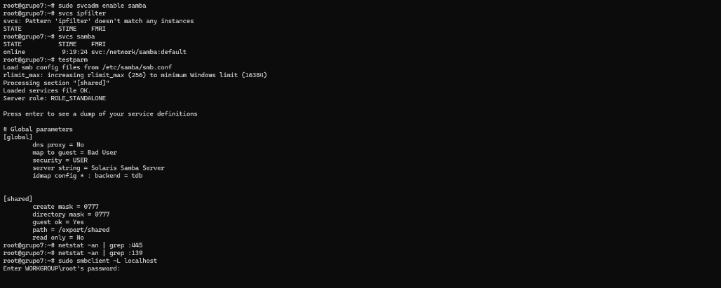
- Configure firewall
For this case, it’s not necessary to open ports to run the firewall

- Test the Configuration
Check if Samba is running:

sudo smbclient -L localhost
testparm # Test configuration file

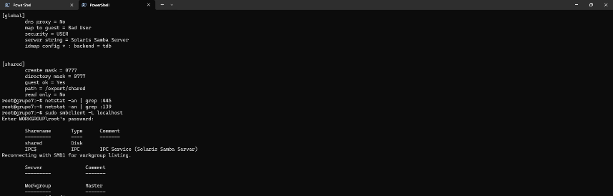

- Troubleshooting
If you have issues:

# Check Samba status
svcs -xv samba

# Check logs
tail -f /var/samba/log/smbd.log

# Check network configuration
ifconfig -a
netstat -an | grep :445

# Check if Samba processes are running
ps -ef | grep smbd
ps -ef | grep nmbd

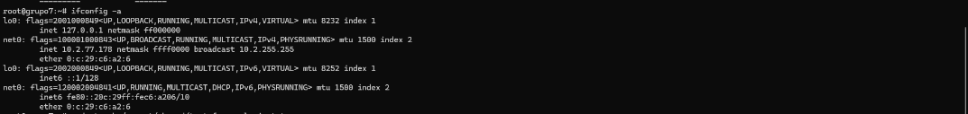

- Quick Test Files
Create some test files in the shared directory:

sudo touch /export/shared/test-from-solaris.txt
echo "Hello from Solaris!" | sudo tee /export/shared/readme.txt
sudo ls -la /export/shared/

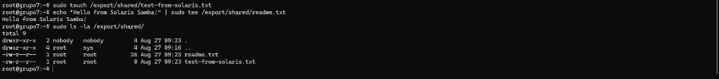
3 — Install Samba package in Slackware to see the Solaris shared folder

- Update and install samba package:

slackpkg update
slackpkg install samba

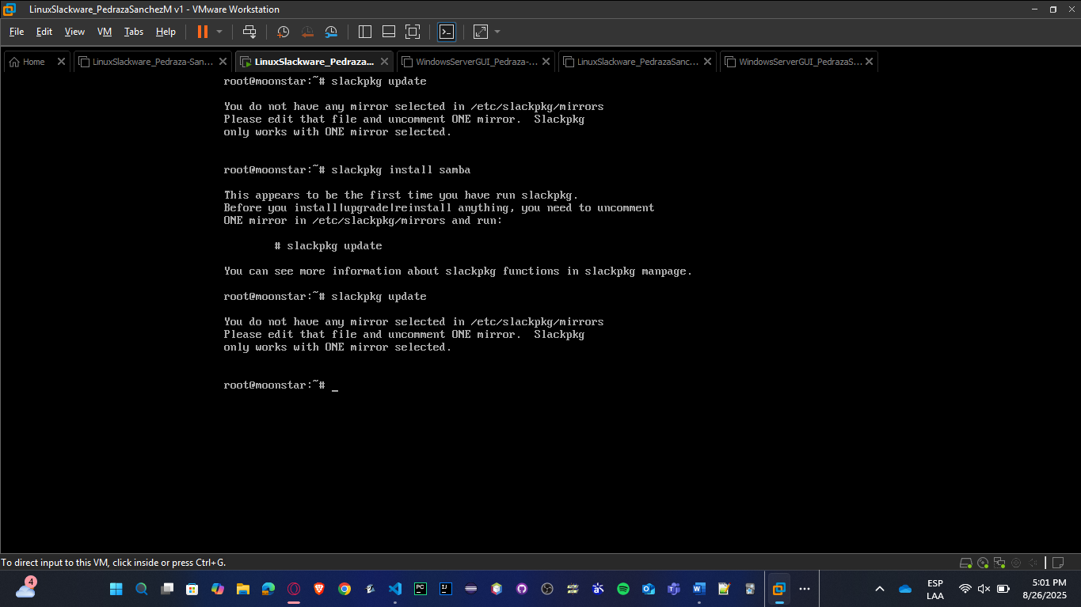

You need to solve a problem related to the lack of mirror selected in /etc/slackpkg/mirrors, so you must uncomment one URL to install samba; this is the process to do:

- Edit the mirrors file
nano /etc/slackpkg/mirrors
You’ll see a long list of mirrors grouped by version (Slackware 15.0, Slackware64 15.0, Slackware-current, etc.).
Now uncomment it (remove the # in one of them):
http://mirrors.xmission.com/slackware/slackware-15.0/ USA Server
Save and exit (Ctrl+O, Enter, Ctrl+X in nano).

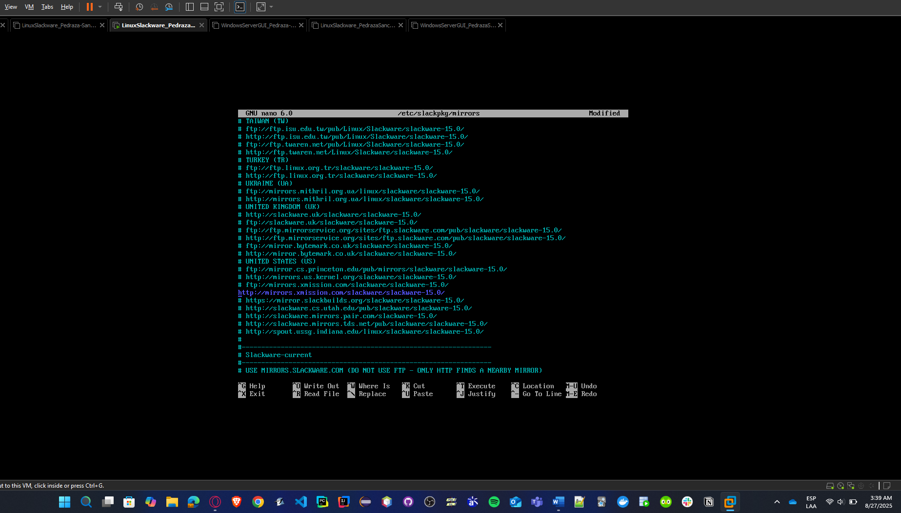

- Skip GPG verification:

# Check current GPG setting
grep CHECKGPG /etc/slackpkg/slackpkg.conf

# If it shows "on", disable it:
sudo sed -i 's/CHECKGPG=on/CHECKGPG=off/' /etc/slackpkg/slackpkg.conf

# Verify the change
grep CHECKGPG /etc/slackpkg/slackpkg.conf

- Install diff command:

# Look for diffutils package
slackpkg search diff
slackpkg install diffutils

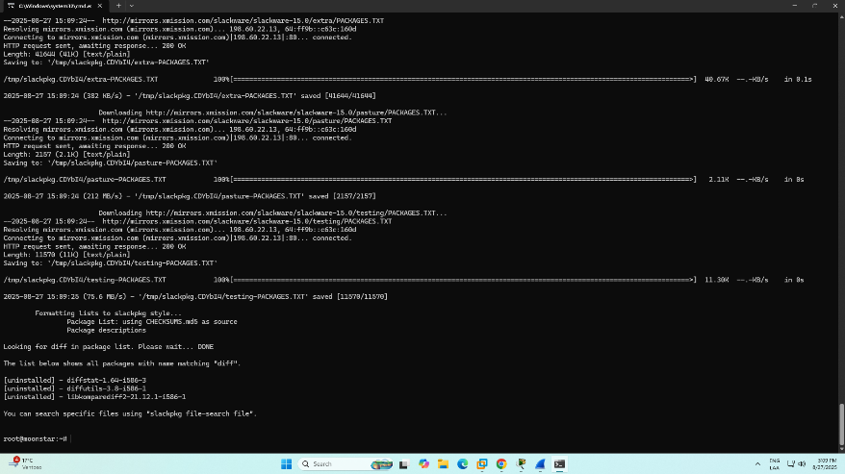

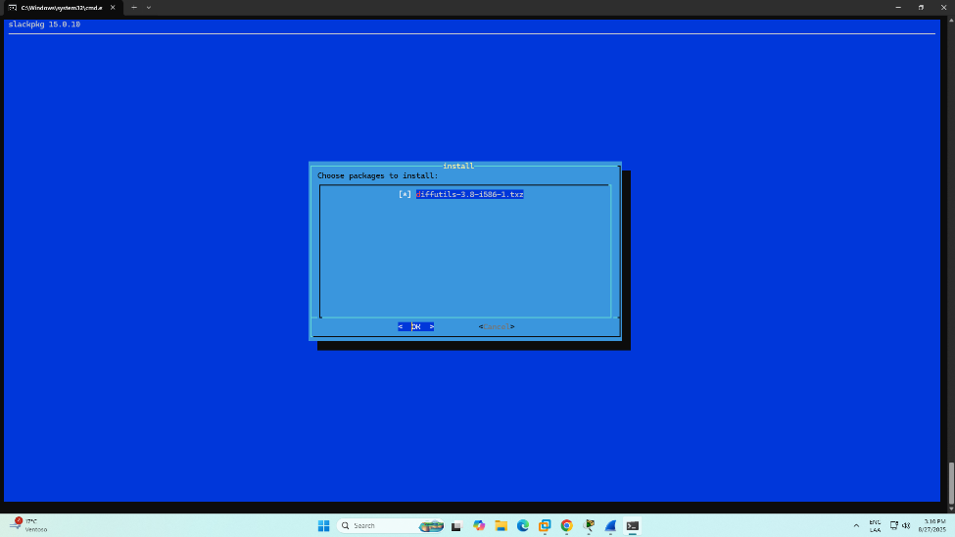

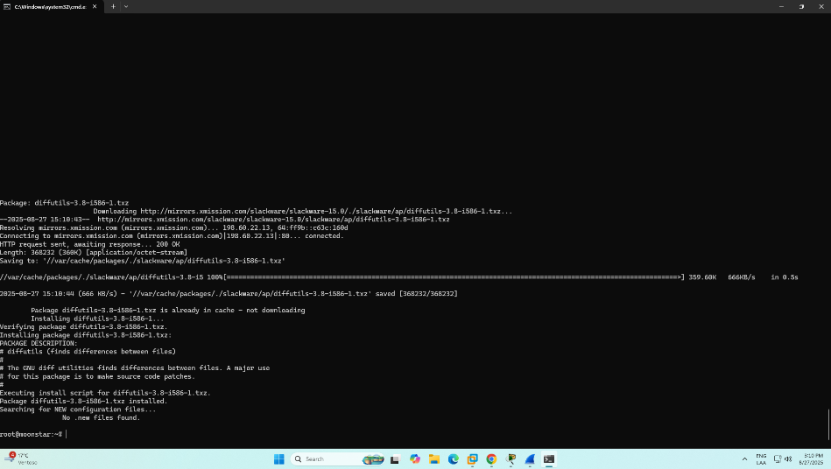

- Repeat the first two commands, and you will see everything is working now, so you can install samba package.

slackpkg update
slackpkg install samba

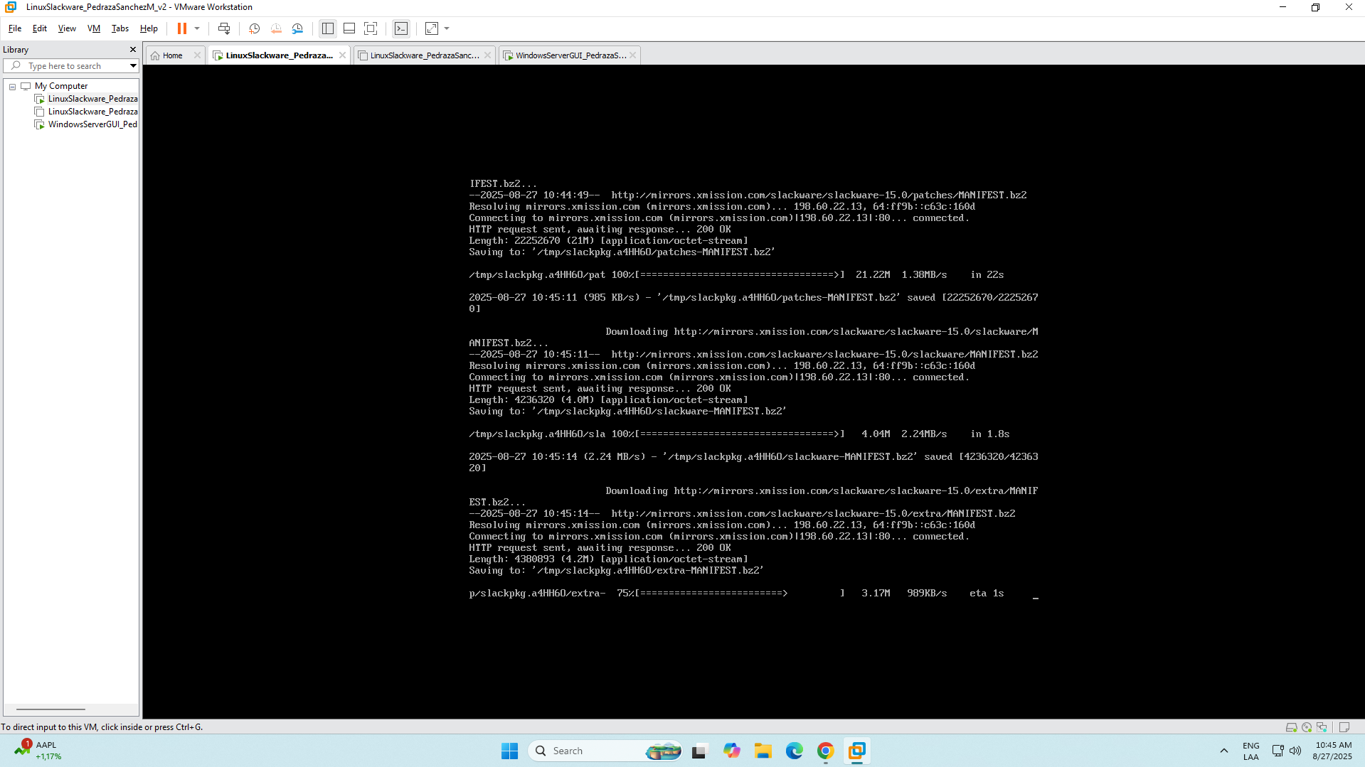

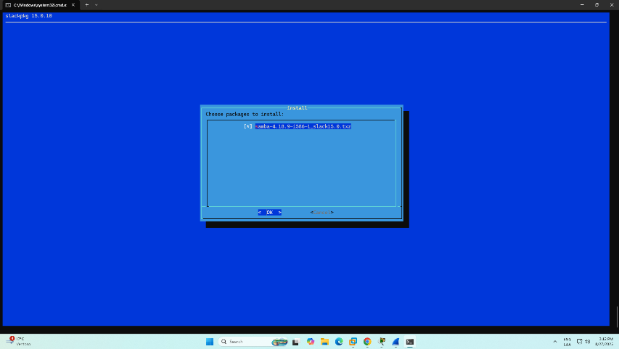
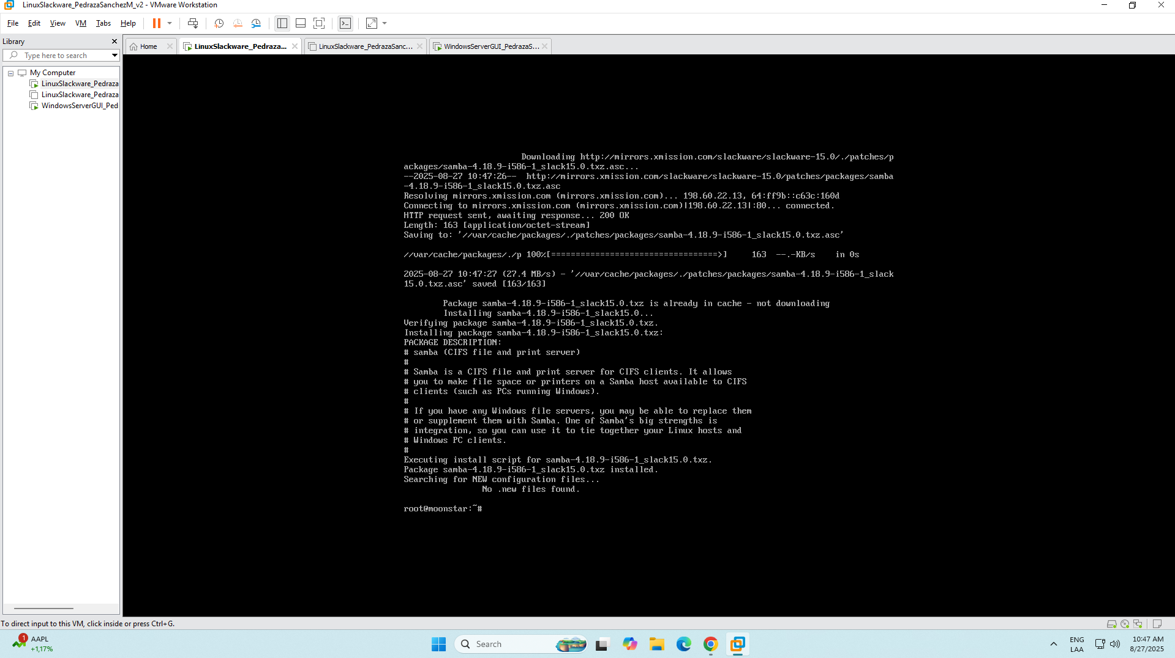
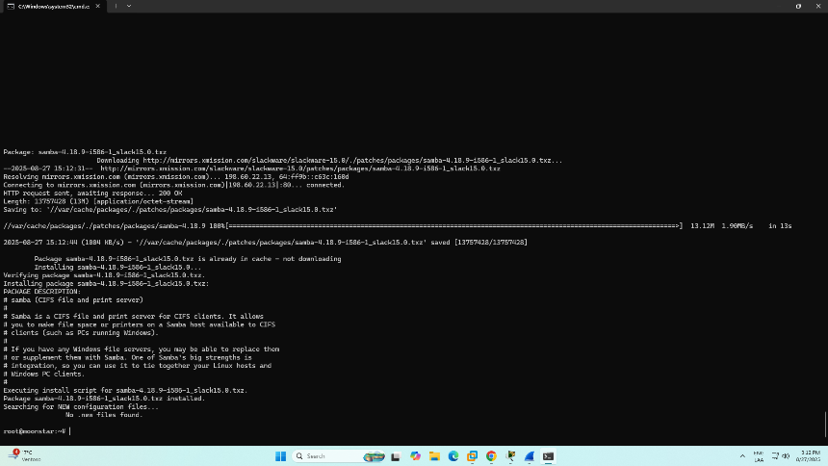

- Then verify:
smbd –version

- Install missing libraries to run command smbclient

- To know all missing libraries at once

# Check what libraries smbclient needs
ldd /usr/bin/smbclient | grep "not found"

# Install ICU (International Components for Unicode)
slackpkg search icu
slackpkg install icu4c

- After that, we will be able to know what libraries we need to install.

# Search for libarchive packages
slackpkg search libarchive

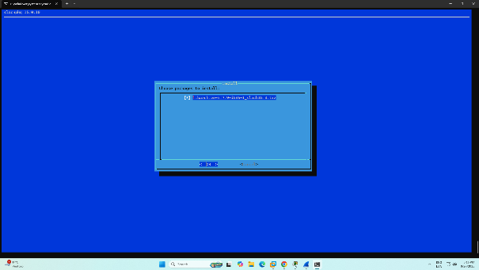

# Install libarchive
slackpkg install libarchive

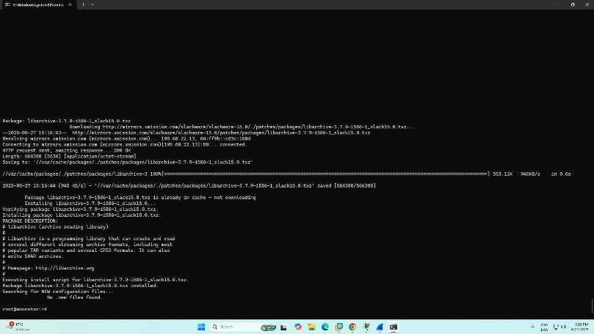

# Search for gnutls packages
slackpkg search gnutls

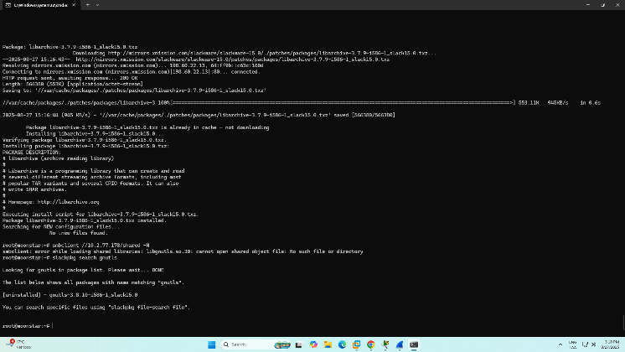

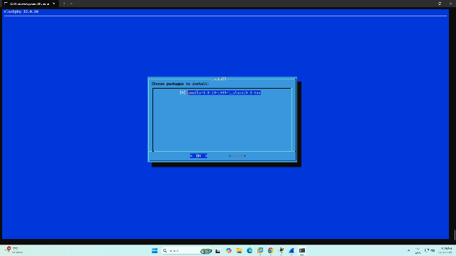
# Install gnutls
slackpkg install gnutls

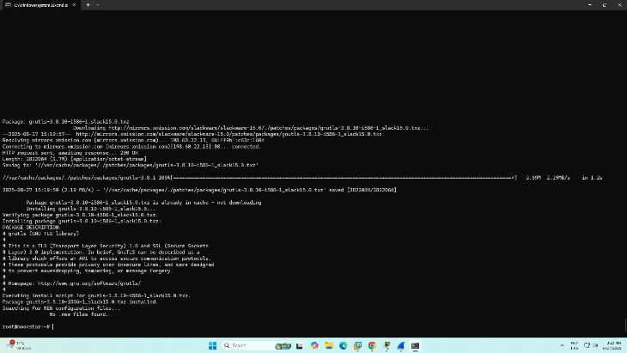

# Install ICU libraries
slackpkg install icu4c

# Install LZ4 compression library
slackpkg install lz4

# Install libxml2
slackpkg install libxml2

# Install Brotli compression libraries
slackpkg search brotli
slackpkg install brotli

# Install p11-kit (PKCS#11 toolkit)
slackpkg search p11-kit
slackpkg install p11-kit

# Install Nettle cryptographic library
slackpkg search nettle
slackpkg install nettle

# Install Jansson JSON library
slackpkg search jansson
slackpkg install jansson
# Install SASL authentication library
slackpkg search sasl
slackpkg install cyrus-sasl

- Test command smbclient

# Test if smbclient is now available
which smbclient

# Test connection to the Solaris Samba server
smbclient //10.2.77.178/shared -N

4 - Solaris shared folder in Windows GUI machine:
- In File Explorer address bar: \\<SLACKWARE_IP>\shared
- When prompted, provide smbuser and the SMB password you assigned.
- If Windows rejects the connection, use \\<IP>\shared instead of hostname, and check Windows SMB client Network security policy if SMB2/3 issues appear.

For this case, you can see the shared folder was added to the machine correctly
